PRESS RELEASE

REVOLUTIONIZING COOLING TECHNOLOGIES FOR A SUSTAINABLE FUTURE

For Immediate Release
Date: 7 October 2024
Location: Chillventa 2024, Nürnberg, 7-212

In line with our vision of reinventing cooling to sustain the world, BAC proudly presents its latest innovations at Chillventa. With a focus on sustainability and efficiency, our latest innovations are addressing the cooling challenges for the most essential and demanding environments on earth.
Energy-Efficient Immersion Cooling for Data Centers
In a revolutionary step for the data center industry, we introduce our immersion cooling solution, designed to cut cooling energy by up to 95% compared to traditional data centre cooling systems​. BAC's system not only extends server life but also requires virtually zero maintenance, significantly reducing operational costs. By ensuring scalability, this solution is future-proof and environmentally responsible.
We will be showcasing the immersion cooling tank at our booth.
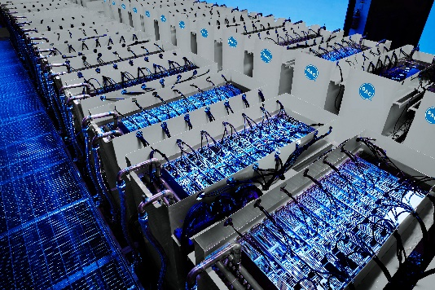

High-Capacity Dry Cooling Solutions for Maximum Efficiency
BAC's TrilliumSeriesTM Dry Cooler, model TDFS provides best-in-class heat rejection with minimal maintenance​. The TDFS cooler offers superb thermal capacity through a combination of vertical coil design and multiple coil circuiting, which reduces pumping energy costs. With a focus on reliability, our dry coolers feature a redundant fan system that remain operational even in the event of signal loss, ensuring continuous operation. The low sound profile and easy accessibility for maintenance make this an ideal choice for operations requiring quiet, low-maintenance, and highly efficient cooling. TDFS dry coolers are designed to meet the increasing demand for sustainable and cost-effective industrial solutions.

3rd Generation PolairisTM Evaporative Condenser: Highest Capacity Condenser
The 3rd generation BAC Polairis™ evaporative condenser, model PLC3 offers the highest capacity in its class, ensuring ultra-quiet operation, unparalleled reliability, and superior hygiene standards.
Equipped with high-efficiency radial fans powered by EC/PM motors, and featuring the advanced DiamondClear® Design, the Polairis™ guarantees long-term, trouble-free, and energy-efficient performance. This exceptional design provides unmatched accessibility and requires minimal maintenance, making it an ideal choice for operational ease. The Polairis™ evaporative condenser continues to deliver top-tier performance for a broad range of applications.
We will be showcasing the Polairis PLC3 at our booth.
As a thank-you gift for our visitors, we're offering a small Lego®-sized Polairis.
5th generation TrilliumSeries products: Sustainable and Cost-Efficient Adiabatic Cooling
The 5th generation BAC TrilliumSeriesTM products offer a game-changing approach to adiabatic cooling systems, thanks to the full-scale testing and development. This rigorous testing ensures an optimized design that maximizes performance and reliability. Hence BAC's 5th generation of TrilliumSeries condensers offer substantial annual cost savings, enhanced thermal capacity, and a rapid return on investment in less than 1.5 years. Additionally, the TrilliumSeriesTM products benefits from unmatched production capacity, supported by our in-house manufacturing of all critical components, ensuring consistent quality and scalability to meet any demand.
We will be showcasing the TrilliumSeries TRC at our booth.
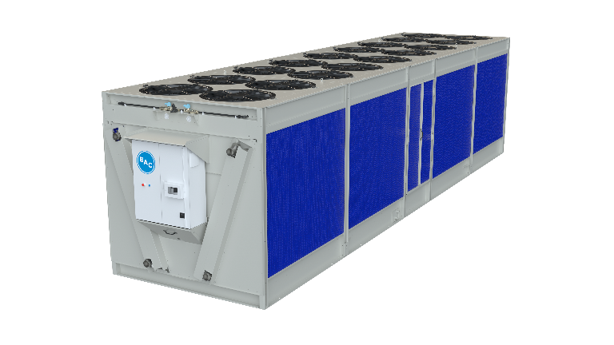
A New Fan Array System: MatrxDriveTM
The MATRXDRIVE™ system is designed to revolutionize cooling systems with its state-of-the-art direct drive design. This innovative system includes permanent magnet motors and integrated variable frequency drives (VFDs) for superior control and energy efficiency. The MATRXDRIVE™ offers exceptional reliability, making it an ideal solution for BAC’s FXVS evaporative closed-circuit coolers and CXVS evaporative condensers. By using multiple fans with a direct drive system, it delivers maximum performance with minimal maintenance, ensuring prolonged operational life and reduced operational costs. Whether for new installations or retrofits, MATRXDRIVE™ is setting new standards in cooling technology.
Smart Factories: Driving Efficiency with Innovation
Our vision extends beyond products to the very way we manufacture. With 3 state-of-the-art facilities in Belgium (1) and Italy (2), we ensure that our production processes are efficient, sustainable, and ready to meet any demand​. Our smart factories embrace intelligent technologies to operate with minimal environmental footprints, and we are showcasing these innovations live at the exhibition.
You are invited to take a virtual tour of our factories by visiting our booth.

Join us at Chillventa, booth 7-212 to experience firsthand how we are transforming cooling technologies for a more sustainable future. Explore our full range of solutions, engage with live demonstrations, and discover how we can help our customers reduce costs, enhance efficiency, and minimize their environmental impact.

About BAC: BAC is proud to be the world’s cooling partner. Since 1938 we have been creating sustainable comfort cooling, process cooling, and refrigeration solutions for the most essential and demanding environments on earth. From pioneering evaporative, hybrid and dry cooling products to leading the industry toward a better tomorrow, BAC innovates for the future, so we can all advance together.
Press release (EN, FR, DE, ES, IT, NL), pictures, logos available to download from:
https://www.baltimoreaircoil.eu/en/press

The small Lego-sized model of PolairisTM evaporative condenser is available for you at BAC booth 7-212. Enjoy the build.

Press Contact:
Lieve Vinckx
Baltimore Aircoil International nv (HQ EMEIA)
Phone: +32 15 257706
Email: LVinckx@baltimoreaircoil.com

